Computer Programming (CSN11101)
ASSIGNMENT-1
Name : Aayansh Niranjan Date : 05/09/2025
Reg_No.: 20253004
Q1. Write a C program that prints “Hello, World!” to the console.
A1. CODE :
#include<stdio.h>

int main(){
printf("Hello World\n");
}

OUTPUT: 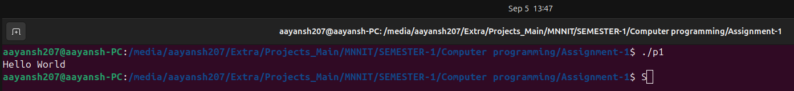

Q2. Write a Program to find the size of int, float, double, and char.
A3. CODE :
#include<stdio.h>

int main(){
int a=5;
float b=6.45;
double c=8.56;
char d='A';
printf("Integer : %lu\n",sizeof(a));
printf("Float : %lu\n",sizeof(b));
printf("Double : %lu\n",sizeof(c));
printf("Char : %lu\n",sizeof(d));
return 0;
}

OUTPUT: 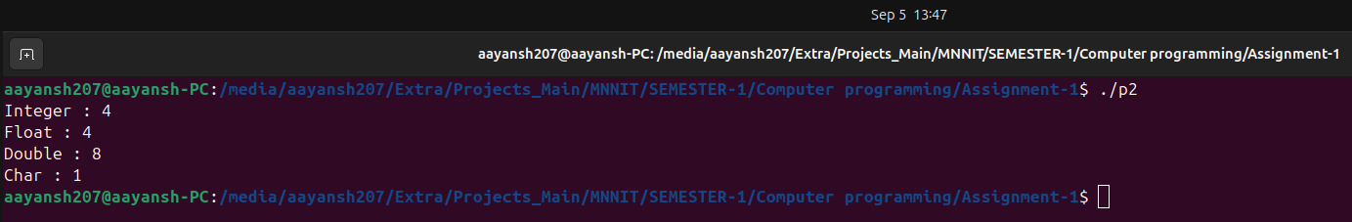
Q3. Write a program that takes two integers as input and performs addition, subtraction, multiplication, and division.
A3. CODE:
#include <stdio.h>

int main(){
int a,b;
printf("Enter the first value : ");
scanf("%d",&a);
printf("Enter the second value : ");
scanf("%d",&b);
printf("Addition : %d\n",a+b);
printf("Subtraction : %d\n",a-b);
printf("Multiplication : %d\n",a*b);
printf("Division : %d\n",a/b);
return 0;
}

OUTPUT:
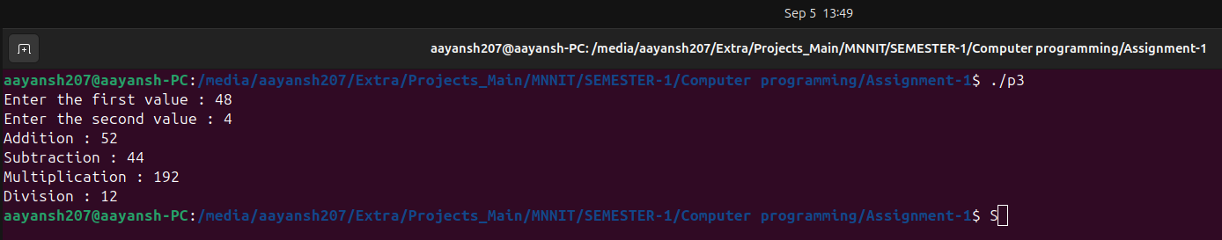

Q4. Write a program to convert temperatures from Celsius to Fahrenheit and vice versa.
A4. CODE :
#include <stdio.h>

int main(){
float c,f;
printf("Enter the celcius temperature : ");
scanf("%f",&c);
printf("The temperature in fahrenheit is : %f\n\n",(c*9/5)+32);
printf("Enter the fahrenheit temperature : ");
scanf("%f",&f);
printf("The temperature in Celcius is : %f\n\n",(f-32)*5/9);
return 0;
}

OUTPUT :
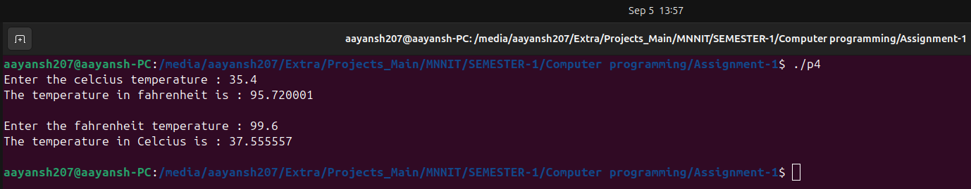

Q5. Write a C program to find the GCD of two numbers.
A5. CODE:
#include <stdio.h>

int main(){
int a,b;
printf("Enter the two values : ");
scanf("%d %d",&a,&b);
while(b!=0){
int c=b;
b=a%b;
a=c;}
printf("The GCD is :%d\n ",a);
return 0;
}

OUTPUT:
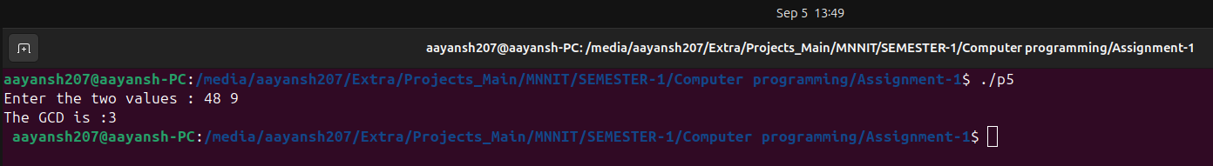

Q6. Write a C Program to find the Maximum and minimum of two numbers without using any loop or condition.
A6. CODE:
#include <stdio.h>
#include <stdlib.h>

int main() {
int a, b, maximum, minimum;
printf("Enter two numbers: ");
scanf("%d %d", &a, &b);
ma = (a+b+abs(a-b))/2;
mi = (a+b-abs(a-b))/2;
printf("Maximum=%d\n",ma);
printf("Minimum=%d\n",mi);
return 0;
}

OUTPUT:


